Graphical Representation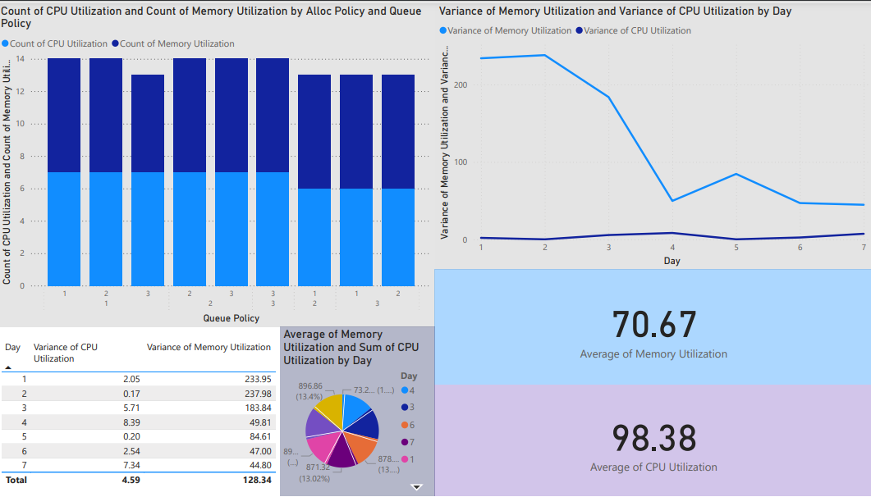

The graphs shown above were extracted from running a simulation for 7 days, whose data was then parsed and processed to form a table (which is given at the end)

Given below are the observations made from the graph

**1. Average Utilization**

* **CPU Utilization**: The average CPU utilization across all policies and days is 98.38%. This suggests that CPU resources are near full capacity, indicating efficient usage but potentially minimal flexibility to handle spikes in demand.
* **Memory Utilization**: The average memory utilization is notably lower at 70.67%, which may imply an opportunity to optimize memory resources or allocate them to other workloads if possible.

**2. Variance in Resource Utilization by Day**

* **Memory Variance**: Memory utilization shows substantial fluctuation, particularly high on Day 1 (233.95) and Day 2 (237.98), with a significant decrease over subsequent days. This trend suggests that memory demand may be dependant on policy
* **CPU Variance**: In contrast, CPU utilization variance is minimal, with values peaking only at 8.39 on Day 4. This consistency indicates stable and predictable CPU usage across policies and days, which aligns with the high average utilization.

**3. Policy-Based Resource Utilization Patterns**

* The bar chart showing the count of CPU and memory utilization by Queue Policy and Alloc Policy highlights a balanced distribution of CPU usage across all policy combinations.
* Memory utilization, however, varies more notably across policies. This suggests that memory demand is more sensitive to policy changes than CPU demand.

**4. Daily Utilization Trends**

* The line chart of variance in memory and CPU utilization by day underscores the initial variability in memory utilization, which stabilizes from Day 4 onward. This pattern suggests a possible adaptation period or efficiency gain in memory management over time.
* The stability in CPU usage further supports the view that CPU demand is consistently high, reinforcing the need to monitor CPU load for any potential overload risks.

**Summary**

This analysis reveals a strong and steady CPU utilization across all days and policies, while memory utilization shows both potential for optimization and responsiveness to different scheduling policies. To maximise efficiency, further attention should be given to understanding the factors driving memory variance, especially in the early days of operation, as well as monitoring CPU usage to prevent potential bottlenecks.

**The Dataset from the simulation**

| **Day** | **Queue Policy** | **Allocation Policy** | **CPU Utilization** | **Memory Utilization** |
| --- | --- | --- | --- | --- |
| **1** | **1** | **1** | **99.74** | **79.35** |
| **1** | **1** | **2** | **99.61** | **80.49** |
| **1** | **1** | **3** | **99.97** | **77.84** |
| **1** | **2** | **1** | **99.15** | **39.98** |
| **1** | **2** | **2** | **95.28** | **51.48** |
| **1** | **2** | **3** | **100** | **56.07** |
| **1** | **3** | **1** | **98.57** | **82.81** |
| **1** | **3** | **2** | **99.84** | **80.81** |
| **1** | **3** | **3** | **100** | **81.29** |
| **2** | **1** | **1** | **99.67** | **71.63** |
| **2** | **1** | **2** | **99.93** | **75.63** |
| **2** | **1** | **3** | **100** | **78.88** |
| **2** | **2-** | **1** | **98.7** | **36.69** |
| **2** | **2** | **2** | **100** | **44.9** |
| **2** | **2** | **3** | **100** | **70.94** |
| **2** | **3** | **1** | **99.77** | **82.65** |
| **2** | **3** | **2** | **99.51** | **76.25** |
| **2** | **3** | **3** | **99.28** | **80.27** |
| **3** | **1** | **1** | **98.7** | **72.94** |
| **3** | **1** | **2** | **99.9** | **70.84** |
| **3** | **1** | **3** | **99.74** | **83.04** |
| **3** | **2** | **1** | **100** | **38.98** |
| **3** | **2** | **2** | **92.12** | **63.94** |
| **3** | **2** | **3** | **99.61** | **76.05** |
| **3** | **3** | **1** | **99.97** | **84.79** |
| **3** | **3** | **2** | **99.58** | **73.45** |
| **3** | **3** | **3** | **99.54** | **85.91** |
| **4** | **1** | **1** | **98.99** | **80.35** |
| **4** | **1** | **2** | **99.64** | **75.09** |
| **4** | **1** | **3** | **99.84** | **78.59** |
| **4** | **2** | **1** | **93.91** | **59.17** |
| **4** | **2** | **2** | **91.34** | **64.99** |
| **4** | **2** | **3** | **99.12** | **67.92** |
| **4** | **3** | **1** | **99.67** | **76.67** |
| **4** | **3** | **2** | **99.09** | **75.44** |
| **4** | **3** | **3** | **99.48** | **80.64** |
| **5** | **1** | **1** | **98.73** | **75.6** |
| **5** | **1** | **2** | **98.73** | **78.39** |
| **5** | **1** | **3** | **99.74** | **78.42** |
| **5** | **2** | **1** | **98.47** | **51.66** |
| **5** | **2** | **2** | **98.21** | **58.63** |
| **5** | **2** | **3** | **98.31** | **65.03** |
| **5** | **3** | **1** | **98.99** | **73.19** |
| **5** | **3** | **2** | **98.47** | **62.79** |
| **5** | **3** | **3** | **99.09** | **76.81** |
| **6** | **1** | **1** | **98.93** | **65.77** |
| **6** | **1** | **2** | **98.5** | **75.73** |
| **6** | **1** | **3** | **98.93** | **75.96** |
| **6** | **2** | **1** | **94.08** | **58.89** |
| **6** | **2** | **2** | **95.54** | **62.43** |
| **6** | **2** | **3** | **97.88** | **67.8** |
| **6** | **3** | **1** | **98.24** | **76.67** |
| **6** | **3** | **2** | **98.01** | **76.28** |
| **6** | **3** | **3** | **98.73** | **78.64** |
| **7** | **1** | **1** | **98.96** | **77.59** |
| **7** | **1** | **2** | **98.5** | **77.05** |
| **7** | **1** | **3** | **98.67** | **76.79** |
| **7** | **2** | **1** | **97.59** | **54.88** |
| **7** | **2** | **2** | **91.31** | **69.18** |
| **7** | **2** | **3** | **92.38** | **68.9** |
| **7** | **3** | **1** | **98.27** | **73.13** |
| **7** | **3** | **2** | **97.33** | **66.93** |
| **7** | **3** | **3** | **98.31** | **72.24** |

**Aman - [iitgcs_24061213]**